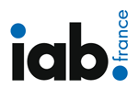
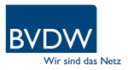
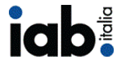
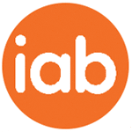
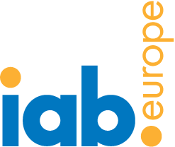
Brand safety and mobile privacy top challenges for mobile advertising according to media agencies across Europe
IAB Agency Snapshot study also reveals that mobile is unlocking new budgets within agencies
Brussels, 17th February 2015: Research released today by IABs Europe, France, Germany, Italy, Spain and UK reveals that approximately 1 in 2 media agency employees want to know more about complying with mobile privacy (57%) and brand safety on mobile (45%).
The IAB Agency Snapshot study, conducted for the first time in France, Germany, Italy and Spain, gives a real insight into the current knowledge of mobile advertising and overall uptake within today’s current media climate. The study was carried out in partnership with YouGov to assess agency approaches to mobile advertising over the last year. The survey which was conducted in November and December 2014 was completed by a total of 154 media agency employees across the five European markets.
Mobile is unlocking new budgets
Encouragingly more than 60% of media agency employees surveyed stated that mobile is a regular part of client proposals.
Nearly half (42%) of media agency employees across Europe claimed that mobile is unlocking new budgets, however a large majority (71%) claimed their mobile budget is coming from other media budgets, such as Internet, TV, Print and Radio.
Integration will be key in 2015 with 82% claiming that mobile will be integrated into their wider agencies by the end of this year.
Key drivers of mobile growth
63% of respondents felt that location based advertising was the most exciting mobile opportunity.
The study also demonstrates that whilst mobile and digital specialists are felt to be the main advocates of mobile advertising within agencies (74% and 76% respectively), strategists are also driving the move to mobile (61%). This suggests that mobile is becoming more mainstream with a stronger understanding across agencies.
Top challenges of mobile growth
Mobile programmatic, brand safety and mobile privacy are all areas of concern for media agencies – all of which came out on top as areas with relatively low levels of understanding.
Nearly 80% of media agencies felt that not being able to track cross screen campaigns was a huge barrier to mobile growth whilst nearly three quarters state that clients’ lack of understanding of mobile advertising is holding back spend on mobile.
Alison Fennah, Executive Business Advisor, IAB Europe said “The collaboration between the local IABs and IAB Europe to produce this study across five European markets is important to gauge the level of mobile understanding across Europe and the key drivers / barriers of growth. It is encouraging to see that new budgets are being found for mobile advertising demonstrating the attraction of the medium for advertising investment.”
The full European results can be accessed here
ENDS
Media please contact: Marie-Clare Puffett – puffett@iabeurope.eu

About IAB Europe
IAB Europe is the voice of digital business and the leading European-level industry association for the digital advertising ecosystem. Its mission is to promote the development of this highly innovative sector by shaping the regulatory environment, investing in research and education, and developing and facilitating the uptake of business standards. Together with its members – companies and national trade associations – IAB Europe represents over 5,500 organisations.
www.iabeurope.eu @IABEurope IAB Europe

